Alias

SELECT ENAME AS "name",
SAL AS "salary",
COMM AS "commision"
FROM EMP;

We can use AS keyword for alias or without AS
We need Double quotes (“ ”), when name includes any space,
If not include spaces we can write without double quotes

SELECT ENAME "Employee Name" FROM EMP;

SELECT ENAME EmployeeName FROM EMP;
SELECT ENAME "Employee_Name" FROM EMP;

Using pipes || - for concatenate
SELECT 'Hello, ' || ENAME
FROM EMP
WHERE JOB LIKE 'PRE%';

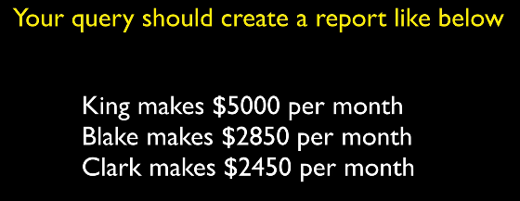
SELECT ENAME || ' makes $' || SAL || ' per month' AS "Employee salary"
FROM EMP;

ORDER BY
SELECT ENAME, SAL
FROM EMP
ORDER BY ENAME ASC;

SELECT ENAME, SAL
FROM EMP
ORDER BY ENAME DESC;

SELECT ENAME, SAL
FROM EMP
ORDER BY SAL DESC;

